

COVID-19 and flu vaccinations, autumn/winter 2022

Communications toolkit for paid and unpaid carers

Introduction

This document has been produced to support paid and unpaid carers to get vaccinated ahead of this winter. It will provide carer charities and other stakeholders with information to help promote understanding of the NHS’s vaccination offer for carers.

Context

In line with advice from the Joint Committee on Vaccination and Immunisation (JCVI), the NHS is offering a further dose of the COVID-19 vaccine this autumn to:

- Residents in a care home for older adults and staff working in care homes for older adults
- Frontline health and social care workers
- All adults aged 50 years and over
- Persons aged 5 to 49 years in a clinical risk group
- Persons aged 5 to 49 years those that live with someone who is more likely to get infections (such as someone living with HIV, has had a transplant or is having certain treatments for cancer, lupus or rheumatoid arthritis)
- Carers

The flu vaccine is offered to people most at risk of getting seriously ill from flu or who are most likely to pass flu to other people at risk. It’s best to have it before flu starts to circulate in the winter. NHS flu vaccine appointments are available throughout the autumn and winter.

The following people will initially be offered the flu vaccine:

- all children aged 2 or 3 years on 31 August 2022
- all primary school aged children (from Reception to Year 6)
- those aged 6 months of age upwards in a clinical risk group
- pregnant women
- those aged 65 years and over
- those in long-stay residential care homes
- carers in receipt of a carer’s allowance, or who are the main carer of an older or disabled person who may be at risk if the carer gets sick
- those that live with someone who is more likely to get infections (such as someone living with HIV, who has had a transplant, or is having certain treatments for cancer, lupus or rheumatoid arthritis)
- frontline health or social care workers (that do not have access to occupational health)

From mid-October 2022, people aged 50 to 64 years old who aren’t in a clinical risk group, will also start to be offered the vaccine after people most at risk have been offered it. Those in this group should wait until mid-October before booking an appointment with their GP practice or a local community pharmacy.

In addition, some secondary school aged children will be offered a flu vaccine by their local school-aged immunisation provider service, most likely later in the season. Parents or guardians of children in a clinical risk group should contact their GP if they would like their child to receive the vaccine earlier in the season.

Key messages

- As a carer or personal assistant, whether paid or unpaid, you’re more likely to be exposed to the flu and COVID-19 viruses.
- If you care for someone who may be at greater risk, it’s easy to pass these viruses on without knowing.
- The risk is particularly high during winter, these when viruses circulate most, so it is better to get protection as early as you can.
- Both flu and COVID-19 can be life-threatening and getting both flu and COVID-19 increases risk of serious illness to you and the person, or people, you care for.
- Even if you’re healthy, you can still catch the flu and COVID-19 viruses and spread them to the person, or people, you care for.
- The flu and COVID-19 vaccines are our best protection against these potentially life-threatening viruses for you and the person, or people, you care for.
- It’s not too late to get your first or another earlier dose of the COVID-19 vaccine. If you need it, you will be welcomed.
- Paid carers may be able to get the COVID-19 booster and flu vaccine through their employer.
- All paid and unpaid carers can book their COVID-19 booster through the National Booking Service, calling 119 for free, or find a walk-in appointment through the online vaccination walk-in finder this site shows which sites can vaccinate people in different age groups)
- COVID-19 vaccines and the flu vaccine can be given on the same day and for people that are eligible for both, you may be able to get both together.
- However, please get each vaccine as soon as you can, for better protection, rather than waiting to get both at the same time as this will not always be possible.

Social media

Twitter  Facebook | COVID-19 is still with us and people can still become very ill. Having your booster will help you to have the best protection ahead of winter.  Book your appointment today at nhs.uk/covid-booster | 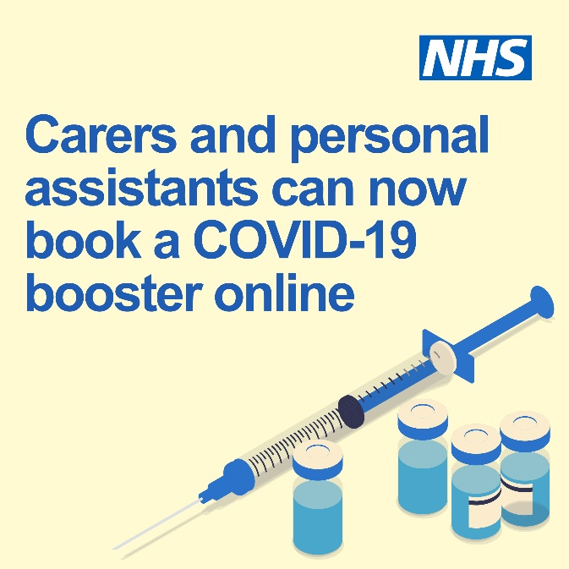
 | COVID-19 is still with us and people can still become very ill. Having your booster will help you to have the best protection ahead of winter.  Book your appointment today at nhs.uk/covid-booster | 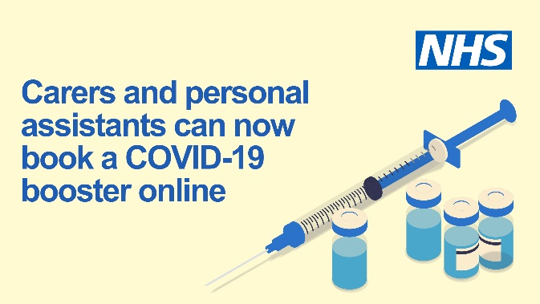
Twitter | Carers and personal assistants are eligible for a COVID-19 booster.  Help protect the person you care for. Book your appointment today at nhs.uk/covid-booster | 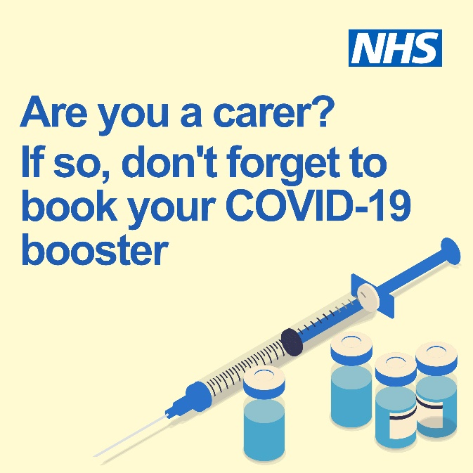
Facebook | Carers and personal assistants are eligible for a COVID-19 booster.  Help protect the person you care for. Book your appointment today at nhs.uk/covid-booster | 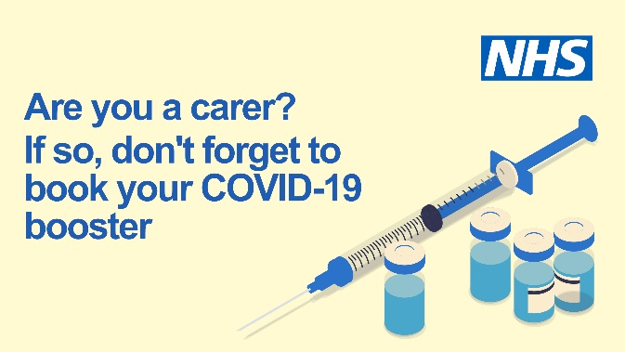
Twitter | Protect yourself and the person you care for ahead of the winter.  Book your COVID-19 vaccination appointment today at nhs.uk/covid-booster | 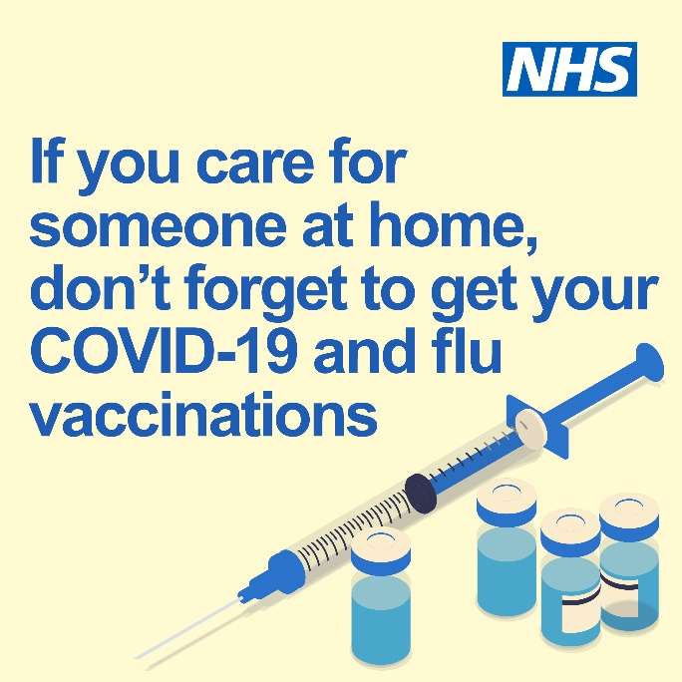
Facebook | Protect yourself and the person you care for ahead of the winter.  Book your COVID-19 vaccination appointment today at nhs.uk/covid-booster | 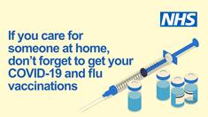

Bulletin copy (internal)
If you’re a carer, you can book your COVID-19 and flu vaccines ahead of winter

As a paid or unpaid carer or personal assistant, you’re more likely to be exposed to the flu and COVID-19 viruses. You also care for people who may be at greater risk and it’s easy to pass these viruses on without knowing.

The flu and COVID-19 vaccines are the best defence against these potentially life-threatening viruses for you and the people you care for.

The flu and COVID-19 vaccines are both now available to carers ahead of winter. If you haven’t got any earlier doses that you need of the COVID-19 vaccine, it’s not too late. You can get these right now and will be welcomed at a local vaccination centre to get up to date.

If you work in a care home, the COVID-19 booster and flu vaccine may be offered through your employer. If not, you can still get the COVID-19 and flu vaccines through the NHS free of charge.

You can book your COVID-19 booster through the National Booking Service, call 119 or find a walk-in appointment through the online vaccination walk-in finder. The flu vaccine may be offered at the same time but if not you can get this at a GP practice or community pharmacy at another time – it’s better to get what you need as soon as you can rather than waiting to have both at the same time.

Bulletin copy (external)
Carers and personal assistants can now get their COVID-19 and flu vaccines ahead of winter
Whether they are paid or unpaid, carers and personal assistants are more likely to be exposed to the flu and COVID-19 viruses. Because they care for people who may be at greater risk, it’s easy to pass these viruses on without knowing.

Both flu and COVID-19 can be life-threatening and getting both flu and COVID-19 increases risk of serious illness. Even healthy people can still catch these viruses and spread them to the people they care for.

The flu and COVID-19 vaccines are the best defence against these potentially life-threatening viruses for carers and the people they care for.

The flu and COVID-19 vaccines are both now available to carers ahead of winter. If you haven’t got any earlier doses that you need of the COVID-19 vaccine, it’s not too late. You can get these right now and will be welcomed at a local vaccination centre to get up to date.

If you work in a care home, the COVID-19 booster and flu vaccine may be offered through your employer. If not, you can still get the COVID-19 and flu vaccines through the NHS free of charge.

Whether you’re a paid or unpaid carer, you can book your COVID-19 booster through the National Booking Service, call 119 or find a walk-in appointment through the online vaccination walk-in finder. The flu vaccine may be offered at the same time but if not you can get this at a GP practice or community pharmacy at another time – it’s better to get what you need as soon as you can rather than waiting to have both at the same time.

Website or blog copy (external)
Carers and personal assistants can now get their COVID-19 and flu vaccines ahead of winter

Both flu and COVID-19 can be life-threatening and getting both flu and COVID-19 increases risk of serious illness. Even if you’re healthy, you can still catch these viruses and spread them to people you care for.

As a carer or personal assistant, either paid or unpaid, you’re more likely to be exposed to the flu and COVID-19 viruses. You also care for people who may be at greater risk and it’s easy to pass these viruses on without knowing.

The flu and COVID-19 vaccines are the best defence against these potentially life-threatening viruses for carers and the people they care for.

The flu and COVID-19 vaccines are both now available to carers ahead of winter. If you haven’t got any earlier doses that you need of the COVID-19 vaccine, it’s not too late. You can get these right now and will be welcomed at a local vaccination centre to get up to date.

If you work in a care home, the COVID-19 booster and flu vaccine may be offered through your employer. If not, you can still get the COVID-19 and flu vaccines through the NHS free of charge.

Whether you’re a paid or unpaid carer, you can book your COVID-19 booster through the National Booking Service, call 119 or find a walk-in appointment through the online vaccination walk-in finder. The flu vaccine may be offered at the same time but if not you can get this at a GP practice or community pharmacy at another time – it’s better to get what you need as soon as you can rather than waiting to have both at the same time.

Other resources

- COVID-19 autumn booster vaccination leaflet (also available in Braille, BSL, large print and translated into 28 languages):
https://www.gov.uk/government/publications/covid-19-vaccination-autumn-booster-resources

- Vaccination campaign resources (please check for updates as materials will be added regularly):

https://campaignresources.phe.gov.uk/resources/campaigns/34-winter-vaccinations-public-facing-campaign

